Caleb
The first task I had to complete was creating the Lego Figure in mechabricks, to then be added to the overall project model. The Lego figure I had created is a Pirate which is on the ship at the cannons, the animation for said Figure is them hitting the cannon in fury with their hand and foot, as you can see in the screenshots below.
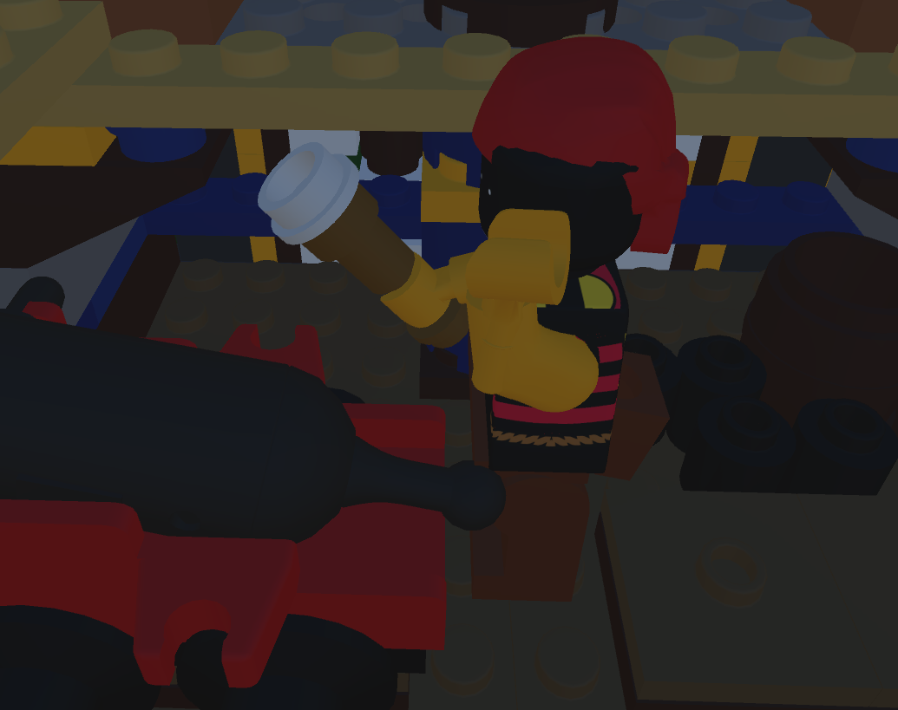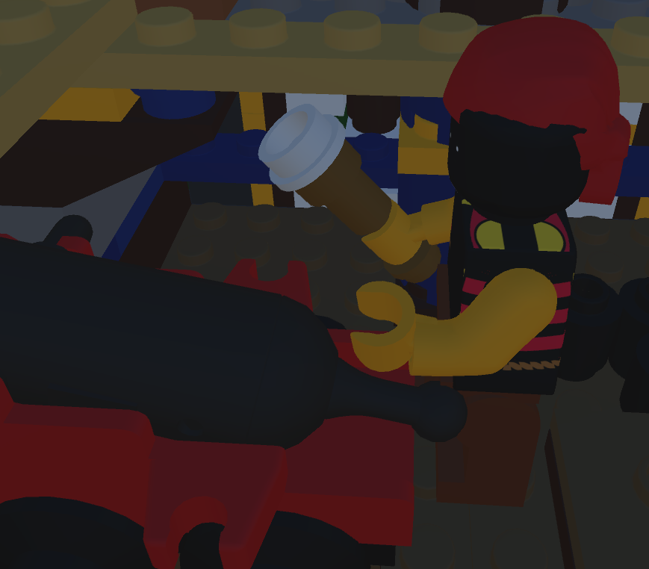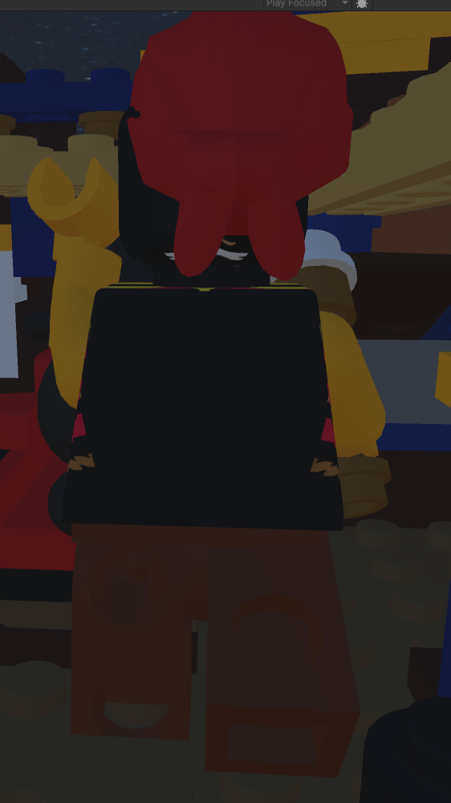
As you can see in the screenshots above, the arm raises up and smacks the cannon and the leg kicks it from below, this is all for the animation of this Lego figure.

Kitty
The first task I had to complete was creating the Lego Figure in mechabricks, to then be added to the overall project model. The Lego figure I had created is a Pirate which is at the end of the ship, the Animation for this Figure is them Jumping up and down with their sword in their hand, as you can see in the screenshots below.
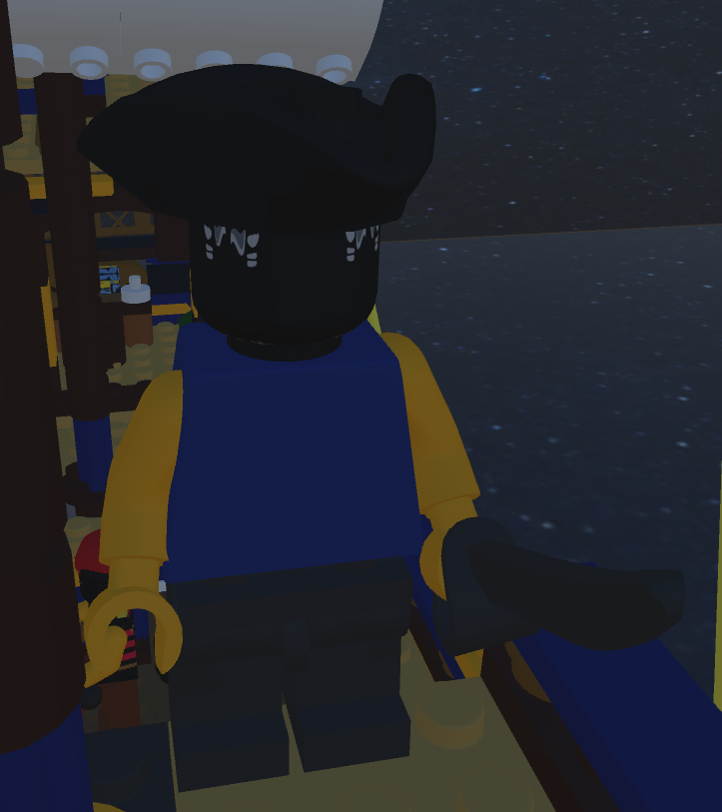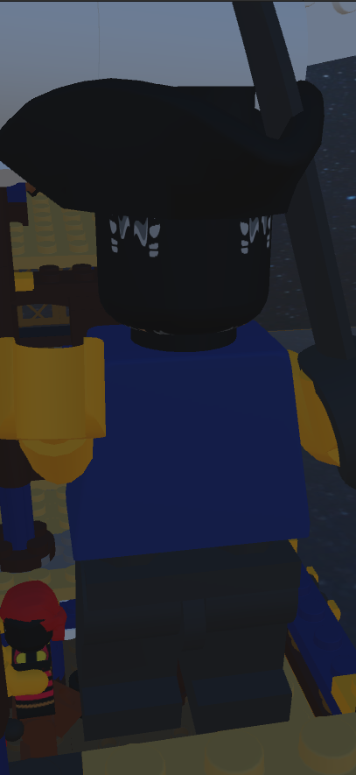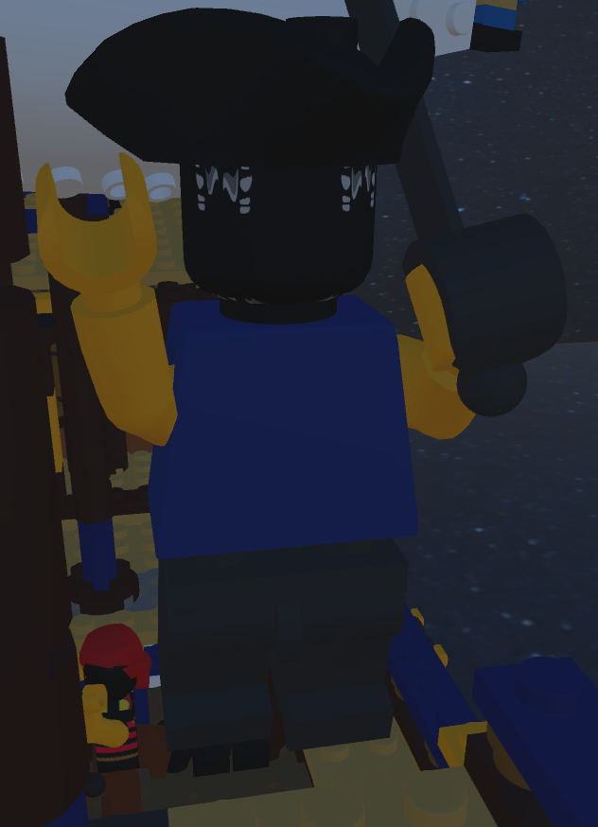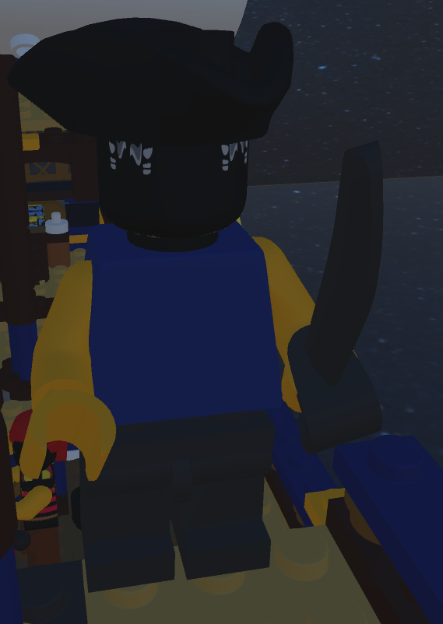
As you can see in the screenshots above, the Pirate starts by standing on the ground then starts his jump, where they raise up their body, arms, sword and legs, then finally reach the height of the jump with arms fully raised to then fall back down.

Szymon
The first task I had to complete was creating the Lego Figure in mechabricks, to then be added to the overall project model. The Lego figure I had created is a Pirate Skeleton, which is on the mast of the ship doing a waving animation with both arms, as you can see in the screenshots below.
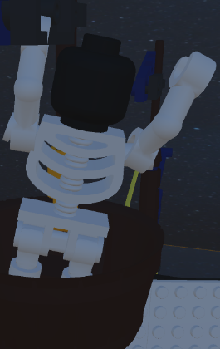
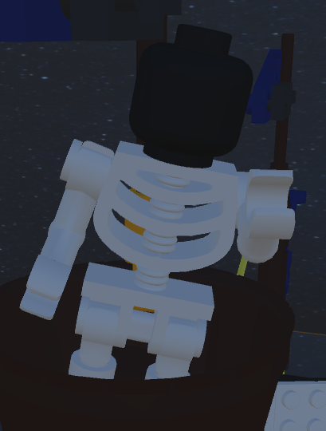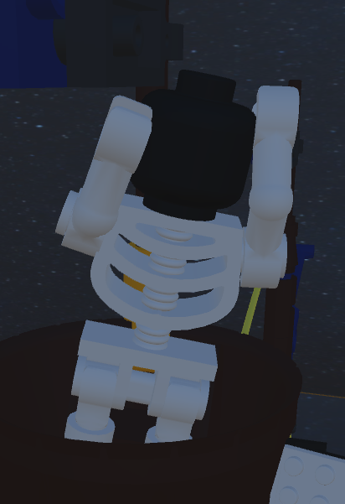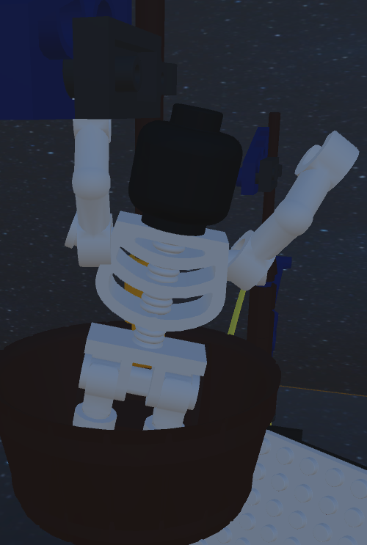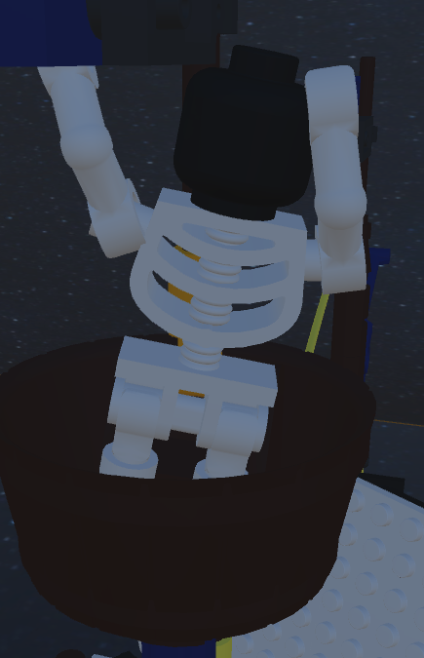
As you can see the skeleton starts in an initial position with one arm coming up, then both are up, then right arm goes outward to start the wave and then goes in as left goes out and then they swap again and return to the start of the animation loop.

Dorcas
The first task I had to complete was creating the Lego Figure in mechabricks, to then be added to the overall project model. The Lego figure I had created is the ship, which has an animation of the sails going from left to right and as ship is being sailed by then captain, as seen in the screenshots below.
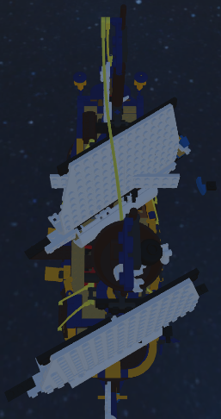
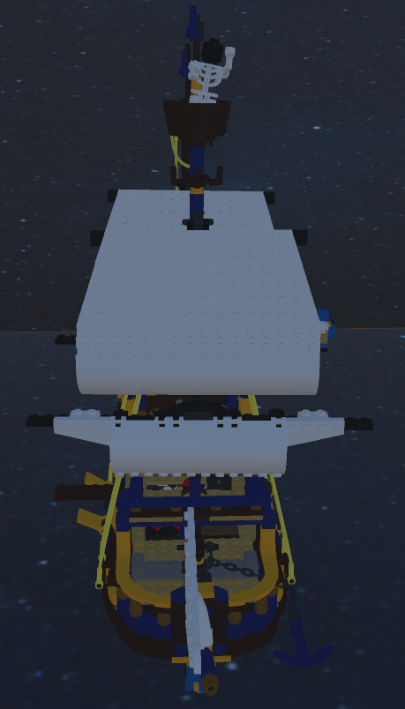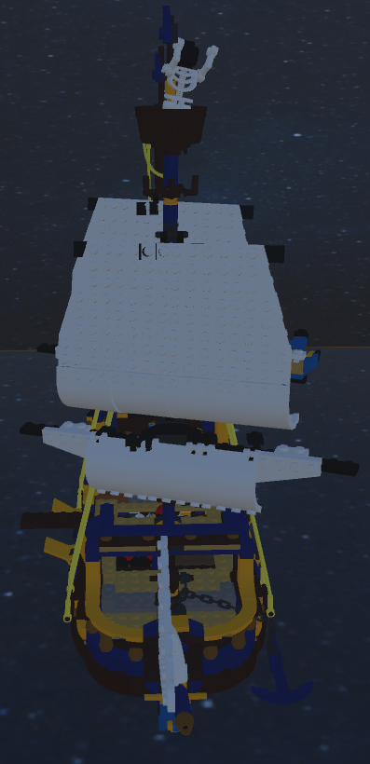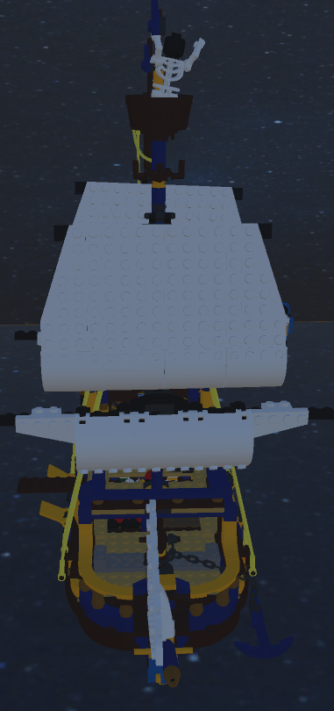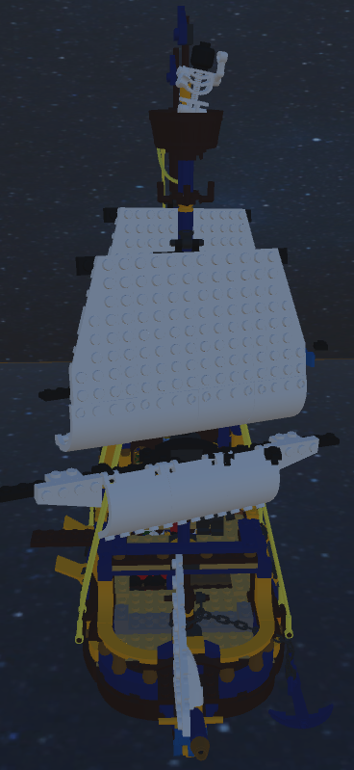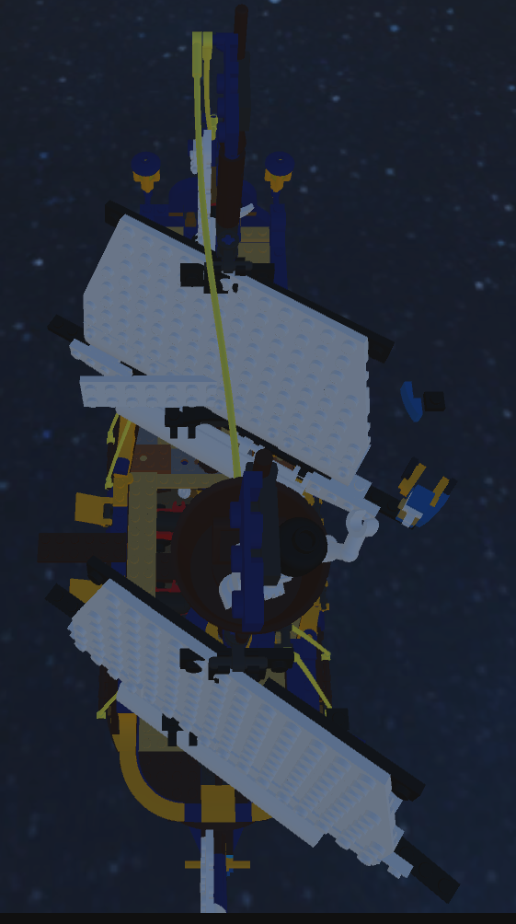
As you can see the ship’s sails start off in their initial position facing forward, then turn to the left, back to middle and then to the right. Ive also made sure that both the front sails and the back sails are animated together.

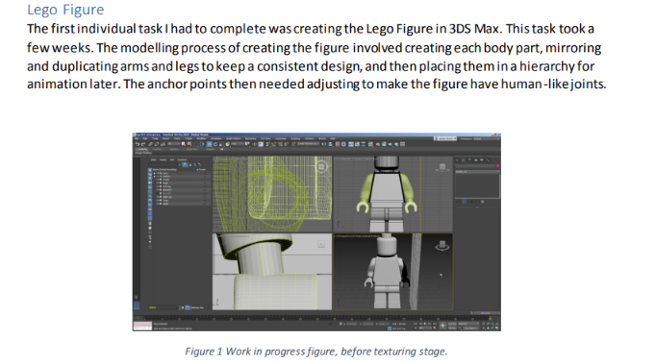

This is what it should look like, so write out the report for minifigures under our names. One minifigure per member and then in your personal report, you talk about how you did the other animations and coding and stuff.
So edit this file and push it the git hub when done.

